Development Review

Customer Requirement Analysis

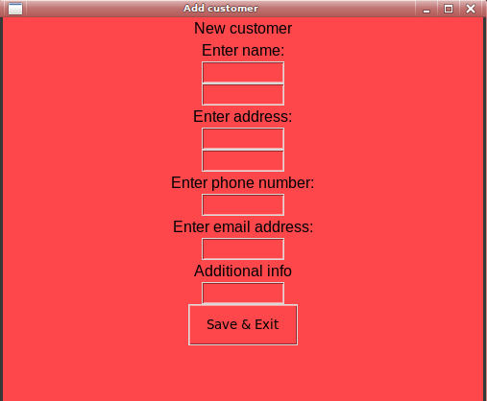
Requirement 1 - Add customer details at any point, including: Firstname, surname, DOB, address ect-
RAG Rating - GREEN

My finished application does allow Mike or any staff member to enter customer data into the database. Using the add customer menu, staff can add all of the appropriate data into the fields, which include: firstname, surname, address1, address2, phone number, email address and additional info. Mike has also confirmed this within the development review questionnaire as seen below:
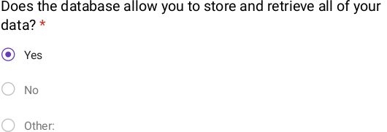

Requirement 2 - Allow silver dawn staff to add trips and events to the database, in order for customers to book. Data stored should include: Duration, dates and cost per passenger.

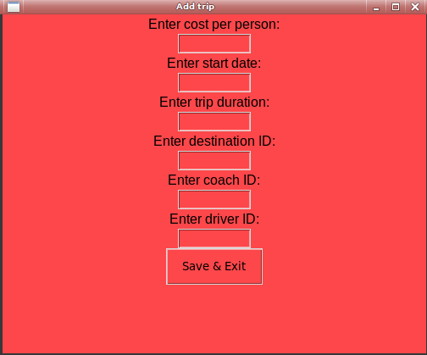
RAG Rating - GREEN

The final application features a trip table, with simplified fields. Fields such as the driver name and coach registration have been removed from the finished product, in order to accomodate for the level of normalisation that was necessary for a reliable
database. (coach, driver and destination were all normalised to improve efficiency). This also improves the fluency of the interface, making it easier for staff to understand the function of each field. Another feature that was previously discussed during the design review was the removal of the end date field and replacing it with an internal calculation which would use the start date and duration to work out the end date, this yet again adds to the simplicity of the design and improves the overall functionality.

Requirement 3 - Enable the booking of coach trips, including: Destination and number of seats.
RAG Rating - GREEN
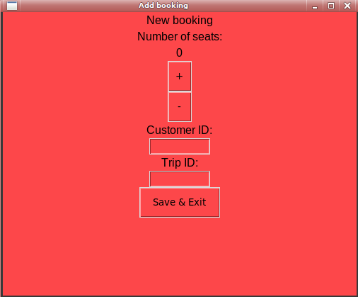
Staff can book trips for customers using the booking menu inside of the main interface. This menu features all of the specified fields collected from Mike’s spreadsheet sent out from his email. These fields include: number of seats customer_id and trip_id, using foreign keys to connect to both the customer table and trip table. This is important, as a customer can have more than one booking, which was considered in the design process. The final program also uses an incrementer to reduce the level of human error within the system: this also removes the need for unnecessary fields, which could contain malicious or accidental data such as: ‘name’ in the data type integer.

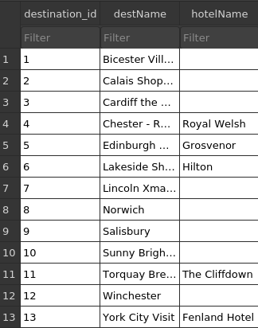
Requirement 4 - Enable silver dawn staff to add destinations.
RAG Rating - GREEN

Destinations can be easily added into the database. As a result of the normalisation process, the destination table is seperate from all other data meaning staff can easily add destinations to collectively return data from all trips with this destination id. This also reduces data redundancy, as only the destination id needs to be called for the entire destination name, further optimising the database.
This menu is also further optimised, with a simplistic design:
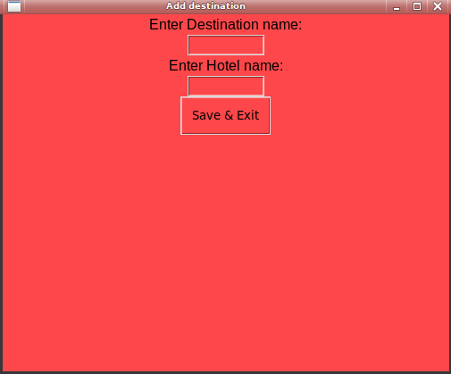

Requirement 5 - User friendly interface, aimed towards staff and Mike.
RAG Rating - GREEN

I have now met this requirement, responding to the feedback received from Mike in the development review questionnaire. The feedback includes: 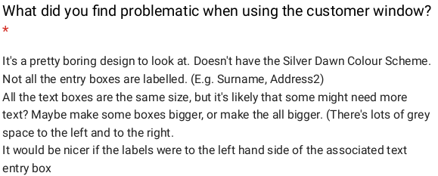
This feedback clearly outlines the colour scheme which has been updated to the appropriate hex values.
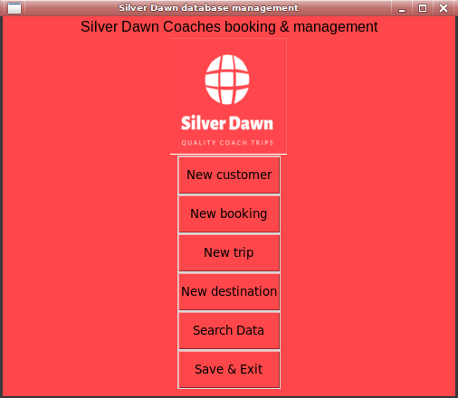
Alongside this, boxes now have a universal size, although i was not able to get text to appear on the left side of the box due to time constraints and design limitations. An exit button was added, calling the exit function in the main menu, allowing Mike to close the application whenever he needs to. The whole process will be terminated, this can only be done from the main menu.

Improvements Based on Feedback

Improvement 1

Feedback

Before
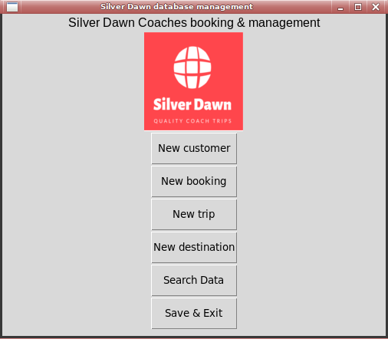

After
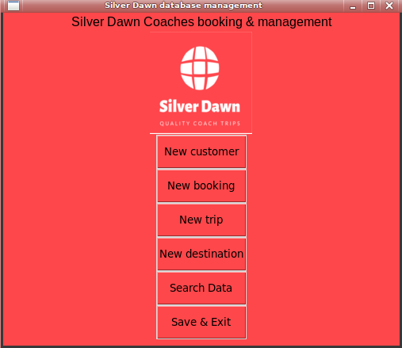

Summary of improvement
This feedback was responded to as it fit nicely with the time constraints I was facing during development, it also would provide a more appealing experience for staff and Mike to use.
I updated each windows background color value to match the logo, using a hexadecimal color picker.
This change should provide a nicer interface for Mike and his staff, effectively improving workflow.

Improvement 2

Feedback
Before
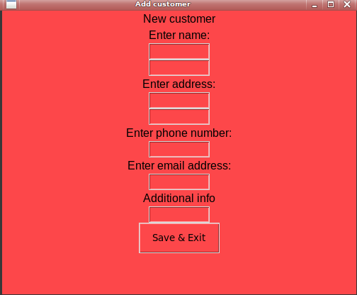

After
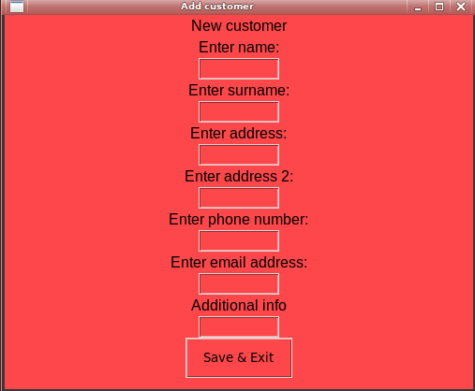

Summary of improvement
I updated the design to better label each input box, allowing staff to see the function of each field.
I added another text value above the missing input boxes, in order to illustrate what they do.
This will help Mike understand what each box does, there is no guesswork involved.

Improvement 3

Feedback

Before
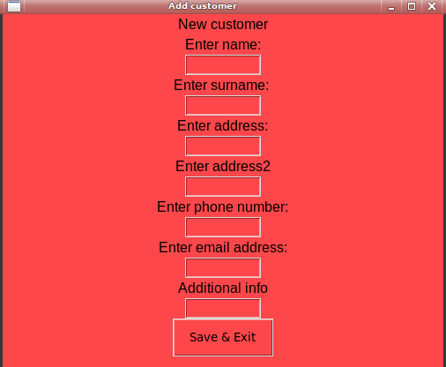

After
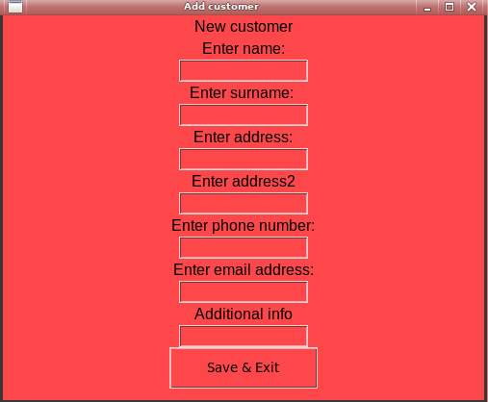

Summary of improvement
I agree with Mike in this instance, as some entries are too long to see all that has been typed in the box, which is why i think this is a valid edit for all fields.
I increased the global width variable to 15 which increased the width of all of the buttons and input boxes.
This will benefit Silver Dawn coaches, as it will improve what staff can see, resulting in less possible errors.

